- Introduction

1.1 Importance of Secure Cloud Storage

In the modern digital era, data is often compared to oil, a highly valuable resource that requires rigorous protection. As cyber threats evolve from simple malware to sophisticated ransomware and data breaches, the security of digital assets has become paramount. Secure cloud storage is no longer just about saving files; it is about ensuring Data Sovereignty and Privacy. Organizations and individuals require systems that guarantee their data is isolated from others, encrypted at rest, and accessible only through verified credentials, protecting them from the growing threat of unauthorized access and data leakage.

1.2 Need for Cost Aware Storage (FinOps)

While cloud adoption has skyrocketed, it has created a new challenge: "Cloud Bill Shock." Traditional storage providers often have difficult pricing models where costs for bandwidth, storage tiers, and API requests accumulate silently. There is a critical need for "FinOps" (Financial Operations) tools, intelligent systems that provide real-time visibility into storage spending. By visualizing cost-per-megabyte and predicting monthly expenses, users can transition from passive consumers to informed managers of their digital footprint, optimizing their usage to prevent financial waste.

1.3 Role of AI in Document Management

We live in an age of "Unstructured Data." A vast majority of digital information exists as "dead" data scanned PDFs, images of invoices, and handwritten notes—that cannot be searched or indexed. The integration of Artificial Intelligence (AI) and Optical Character Recognition (OCR) transforms this passive storage into active intelligence. By automatically extracting context (emails, phone numbers, URLs) from images, AI bridges the gap between physical documents and digital productivity, turning a simple file locker into a powerful intelligent assistant.

1.4 Web-Based Secure Management Systems

A robust backend is useless without an accessible frontend. Web-based management systems democratize access to complex cloud infrastructure. They provide a unified interface where users can manage files, view analytics, and perform security audits from any device, anywhere in the world. These systems must balance Usability (drag-and-drop interfaces, dashboards) with Security (Role-Based Access Control, Session Management) to ensure a seamless yet safe user experience.

1.5 Academic and Practical Relevance

The CloudVault project represents a convergence of multiple advanced computer science disciplines. It integrates Full Stack Development (React/FastAPI), Cloud Infrastructure (MinIO/S3), Database Management (PostgreSQL), and Artificial Intelligence (Gemini/Tesseract). Academically, it serves as a practical implementation of the "Lakehouse" Architecture and Microservices Design Patterns, offering a comprehensive case study in building production-ready, scalable software solutions.

- Objectives

2.1 Primary Objectives

- To design and develop a secure, multi-tenant cloud storage application using Folder-Based Isolation.

- To implement real-time cost analytics that visualize storage spending ($/MB) and usage trends.

- To integrate AI-powered OCR tools (Gemini AI & Tesseract) for extracting contact details from documents.

- To ensure secure file sharing via time-bound, encrypted links.

2.2 Secondary Objectives

- To implement a secure password authentication system using OTP simulation.

- To design a responsive, dark-mode enabled user interface using React and Tailwind CSS.

- To manage unstructured data efficiently using MinIO Object Storage.

- To enhance skills in Python (FastAPI), React.js, and Cloud Infrastructure logic.

- Utility of Project

3.1 Enterprise and Cost Management Utility

CloudVault is highly useful for small to medium enterprises (SMEs) that need to manage digital assets while keeping a strict eye on costs. The "Cost Monitor" module allows administrators to predict monthly bills and optimize storage usage, directly addressing the industry need for cost transparency.

3.2 Data Entry and Administrative Utility

The integrated OCR Tools provide immense utility for administrative professionals. By automatically scanning business cards and documents to extract emails, phone numbers, and URLs, the system reduces manual data entry errors and speeds up digitization workflows.

3.3 Personal Privacy and Security

For individual users, the project offers a secure "Vault" where files are isolated. The ability to generate temporary, self-destructing share links ensures that users maintain control over their data even after sharing it, a key requirement in personal cybersecurity.

3.4 Academic Utility

From an academic perspective, this project demonstrates the implementation of a modern "Lakehouse" architecture (combining Database and Object Storage) and Microservices principles (separating OCR, Auth, and Storage logic), serving as a comprehensive case study for Full Stack Engineering and a demonstration of modern DevOps and Engineering principles. It moves beyond simple "CRUD" (Create, Read, Update, Delete) applications to handle complex binary data streams, third-party AI API integration, and containerized storage services, preparing students for real-world software engineering challenges.

- Problem Statement

In the current digital ecosystem, users and organizations face a "Triad of Challenges" regarding data storage, which this project aims to solve:

4.1 The Risk of Data Vulnerability in Shared Environments: Most basic storage applications fail to implement strict multi-tenancy. In a shared environment, if one user's data is not logically and physically isolated from another's, it creates a massive security risk. A simple permission error can lead to Data Leakage, where confidential files become accessible to unauthorized users. There is a lack of systems that enforce rigorous "Folder-Based Isolation" at the architectural level.

4.2 The "Black Box" of Cloud Costs (Financial Opacity): Public cloud providers (like AWS, Google Drive, Azure) often have complex, tiered pricing models that are incomprehensible to the average user. Organizations frequently suffer from "Bill Shock" realizing too late that they have overspent on storage. Existing tools lack a simple, real-time "Cost Dashboard" that translates technical usage (Gigabytes) into financial terms (Dollars), leaving users blind to their spending until the invoice arrives.

4.3 The Inefficiency of "Dark Data" (Unstructured Content): Billions of gigabytes of data stored today are "Dark Data"—scanned images, PDFs, and screenshots that are stored but not usable. A user cannot search for a phone number inside an image of a business card stored in a standard folder. This leads to Information Paralysis, where valuable insights are locked away in static files, requiring tedious manual transcription to become useful.

4.4 Complexity of Secure Sharing: Securely sharing a file usually requires creating accounts or navigating complex permission settings. Users often resort to insecure methods like email attachments or public links that never expire, leading to Permanent Data Exposure. There is a lack of simple tools that allow for "Time-Bound" sharing (e.g., "Grant access for 1 hour only") without complex configuration.

- Analysis of the Project

5.1 Data Flow Diagram (0-Level DFD)
The 0-Level DFD represents the high-level interaction between the User and the CloudVault System.

- Input: User uploads files, provides OTP for login, or uploads images for scanning.

- Process:
- Auth Module: Validates OTP and issues session tokens.

- Storage Module: Isolates the file to bucket/{user_id}/ and returns a secure ID.

- Analytics Module: Calculates file size, updates the cost database, and triggers dashboard updates.

- AI Module: Routes image data to Gemini AI or Tesseract based on availability.

- Output: The System returns success notifications, updated cost charts, and structured JSON data (Contacts/Urls) from OCR.

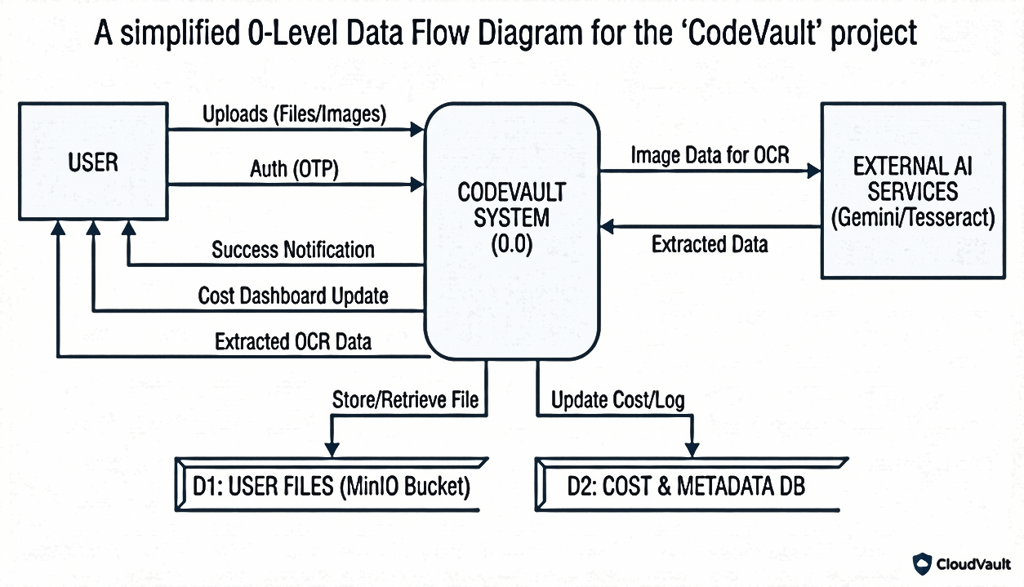
Data flow diagram of CodeVault

  - Entity Relationship Diagram (ERD) Overview

- Entities and Attributes:
  - User: Represents the registered account holder.
    - Attributes: id (PK), email, password, name.

  - File: Represents the digital assets uploaded by users.
    - Attributes: id (PK), filename, s3_key, size_bytes, content_type, uploaded_at, user_id (FK).

  - Analytics: Stores point-in-time cost and usage metrics for dashboard visualization.
    - Attributes: id (PK), user_id (FK), total_files, total_size_mb, current_cost, recorded_at.

  - Contacts: Stores data parsed from documents via the AI-OCR engine.
    - Attributes: id (PK), raw_text, extracted_email, extracted_phone, created_at.
- Relationships:
  - One-to-Many (User ↔ File): A single User can upload multiple Files.

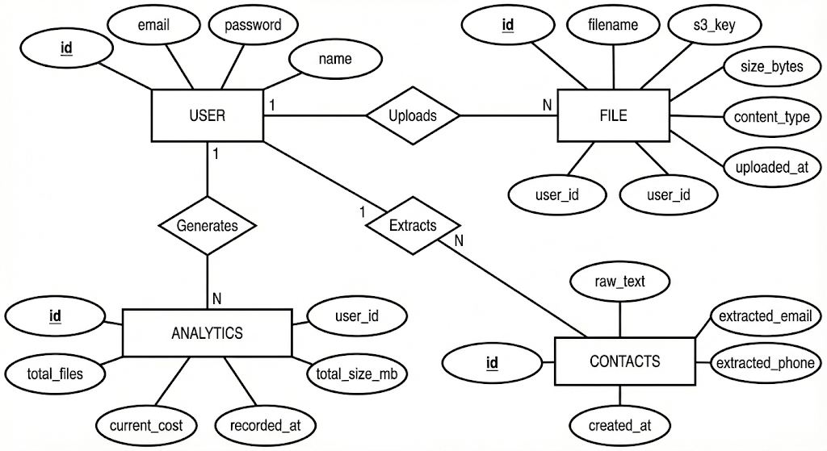
  - One-to-Many (User ↔ Analytics): A single User generates multiple Analytics records over time (History).

- Complete Structure

6.1 Modules and Their Brief Description

- Presentation Layer (Frontend Module)

Built with React.js and Tailwind CSS. It handles the UI for File Management, the Dashboard for Cost Analytics, and the Camera interface for OCR scanning.

- Application Layer (Backend API Module)

Built with FastAPI. It routes requests, handles OTP authentication, and enforces security headers (x-user-id).

- Storage Engine (Object Storage Module)

Uses MinIO to simulate AWS S3. It manages the physical storage of files, organizing them into unique "User Folders" to ensure isolation.

- Intelligence Layer (AI-OCR Module)

A hybrid engine that attempts to use Gemini AI for advanced context extraction and falls back to Tesseract OCR for offline processing.

- Analytics Layer (Cost Module)

A background service that aggregates total file sizes per user and calculates dynamic costs (simulated at $0.10/MB).

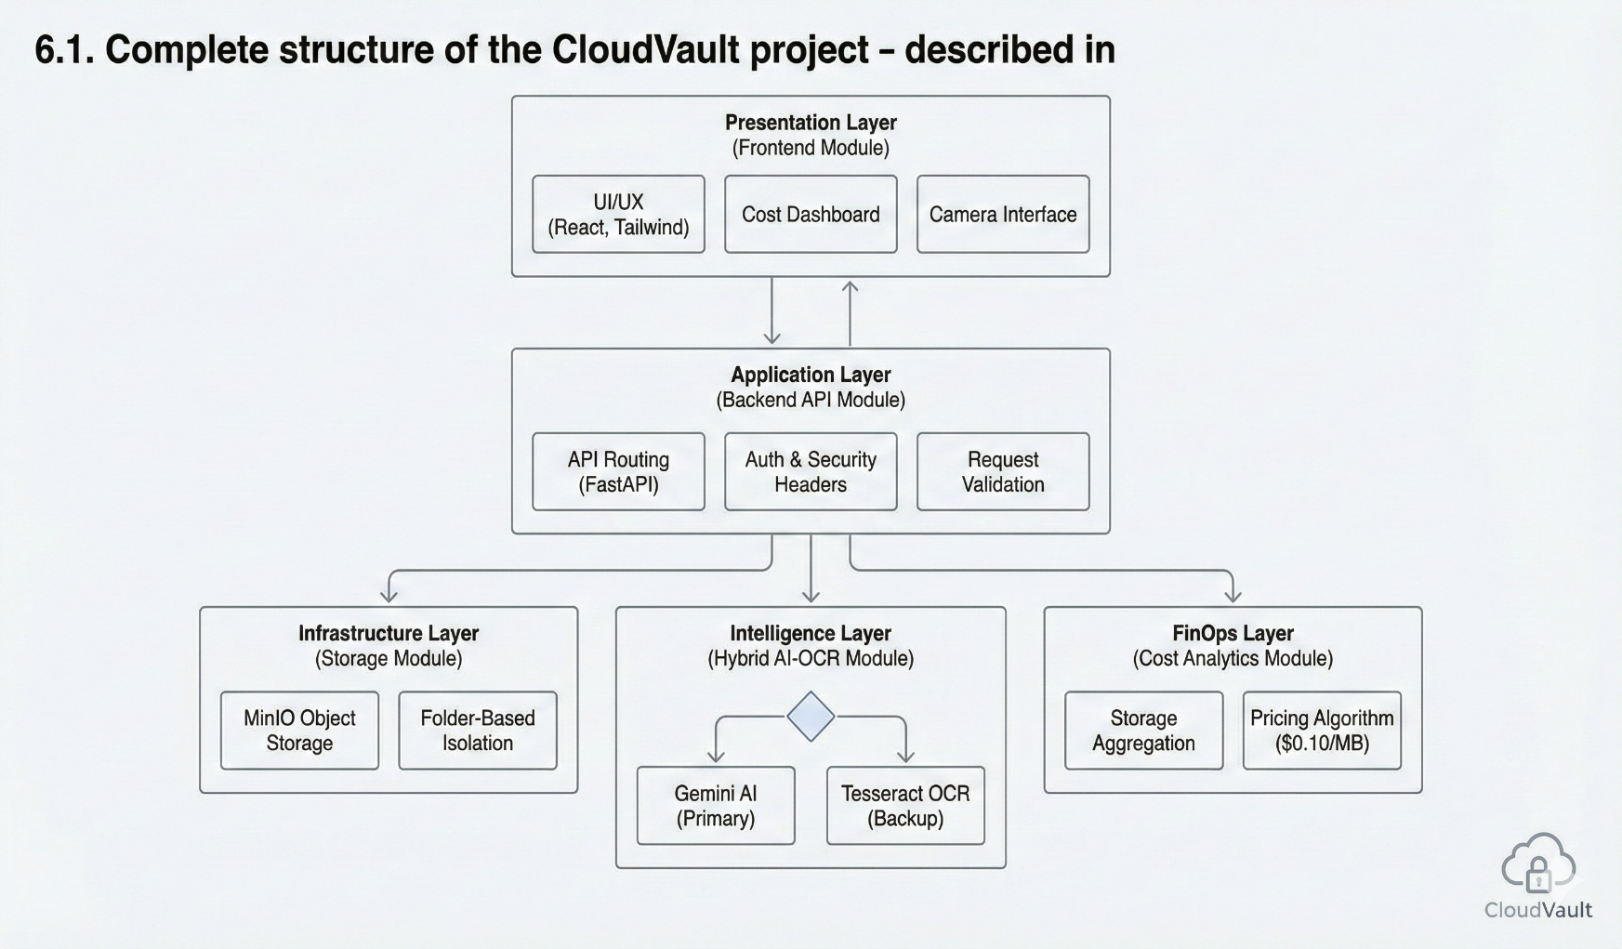

6.2 Tentative Format of Reports Generation

- Storage & Cost Report: A summary dashboard showing "Total Storage Used" (MB/GB) and "Projected Monthly Cost" ($).

- Usage Trend Graph: A line chart visualizing how storage costs have fluctuated over the period.

- OCR Extraction Report: A visual card format displaying extracted fields (Name, Phone, Email, URL) with direct "One-Click Action" buttons (e.g., "Call Now", "Send Email").

- Tools / Platform

7.1 Hardware and Software Requirements

  - Hardware Requirements

- Processor: Intel Core i5 / Ryzen 5 or higher (for running MinIO and AI models).

- RAM: 8 GB minimum (16 GB recommended).

- Storage: 50 GB free space.

- Internet: Stable connection for accessing Gemini AI APIs

  - Software Requirements

- OS: Windows 10/11, Linux or macOS.

- Code Editor: VS Code.

- Containerization: Docker (for MinIO and Postgresql).

- API Client: Postman or Browser DevTools.

- Runtime Environment: Node.js (v18+), Python (v3.9+).

7.2 Project Platform and Languages

- Frontend: React, Vite, Axios, Recharts, Lucide-React.

- Backend: FastAPI, Uvicorn, SQLAlchemy, Pydantic.

Artificial Intelligence:

- google-generativeai: For Gemini Pro Vision API and main OCR for best output.

- pytesseract: For Optical Character Recognition as a backup.

- Pillow (PIL): For image processing.

- Infrastructure: MinIO Server, PostgreSQL.

7.3 Project Development Schedule (Gantt Chart)
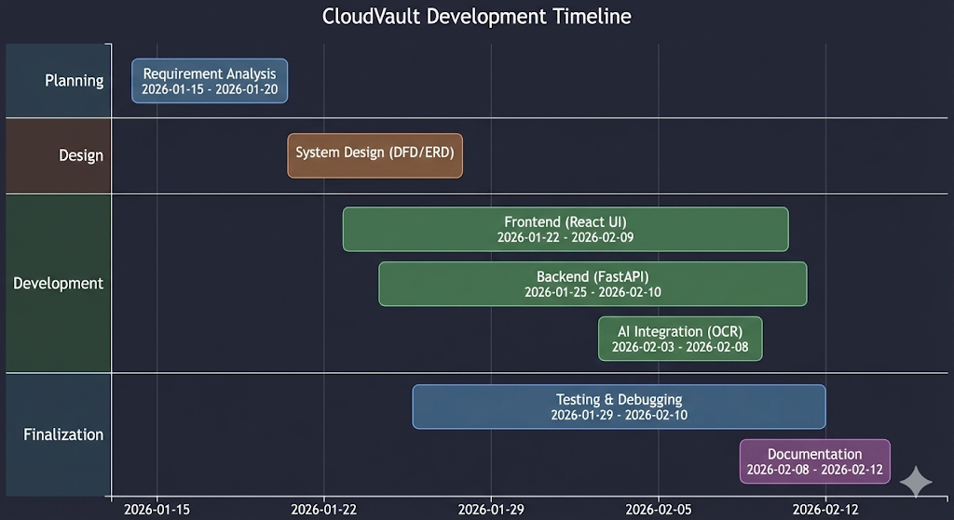

- Conclusion

CloudVault successfully demonstrates the future of Personal Cloud Storage by converging three critical pillars: Security, Intelligence, and Transparency.

Unlike traditional storage solutions that function as passive "digital lockers," CloudVault operates as an active "Intelligent Asset Manager." By integrating Folder-Based Isolation, it solves the critical security flaws inherent in multi-tenant architectures. By embedding a Real-Time Cost Engine, it brings financial clarity to cloud usage, solving the problem of opaque billing. Finally, by deploying a Hybrid AI-OCR Engine, it unlocks the value of unstructured data, proving that storage systems can be productivity tools, not just dumping grounds.

The successful implementation of the "Hybrid" AI model—combining the advanced reasoning of Google Gemini with the offline reliability of Tesseract—ensures the system is both powerful and resilient. The project stands as a production-ready prototype that adheres to modern software engineering standards, utilizing a Microservices-ready architecture that is scalable, secure, and user-centric. Future enhancements, such as mobile application integration and multi-cloud redundancy, would further cement its position as a comprehensive solution for modern data management challenges.

- Future Scope

The current implementation of CloudVault establishes a robust foundation for secure, intelligent cloud storage. However, the system has significant potential for further expansion and technological enhancement:

- Native Mobile Application Development: Currently, the system operates as a responsive web application. Future iterations will focus on developing native mobile applications (using React Native or Flutter) to utilize on-device hardware features like Biometric Authentication (Fingerprint/FaceID) for even more secure login and direct Camera Integration for smoother document scanning.

- Blockchain-Based Audit Trails: To further enhance the "Secure" aspect of CloudVault, future versions can integrate Blockchain Technology to create an immutable, tamper-proof ledger of all file access logs. This would guarantee that no file interaction (upload, download, or delete) can ever be hidden or altered, making the platform suitable for legal and forensic use cases.

- Automated Workflow Triggers (IFTTT): The system can be extended to support "Smart Workflows." Using the AI-OCR engine, the system could automatically categorize files and trigger actions. For example, if the AI detects an "Invoice," it could automatically move the file to a "Finance" folder and email a copy to an accountant, reducing manual file organization.

- Multi-Cloud Redundancy (RAID for Cloud): To prevent data loss from a single point of failure (e.g., if one MinIO server goes down), the architecture can be upgraded to support Multi-Cloud Sharding. This would split and store encrypted file chunks across different providers (e.g., AWS S3, Google Cloud, and Azure) simultaneously, ensuring 100% data availability even during major outages.

- Advanced FinOps & Budget Forecasting: While the current system tracks real-time costs, future improvements will include Machine Learning-based Forecasting. By analyzing a user's upload history, the system could predict their bill for the next 6 months and alert them before they exceed their budget, moving from "Descriptive Analytics" to "Predictive Analytics."

- Bibliography

- FastAPI Framework

FastAPI Official Documentation. Used for building high-performance backend APIs and implementing security dependencies.
  - Available at: https://fastapi.tiangolo.com/

- React Documentation

React.dev. Used for component-based UI architecture and state management hooks.
  - Available at: https://react.dev/

- MinIO Object Storage:

MinIO Documentation. Referenced for implementing S3-compatible bucket policies and file isolation.
  - Available at: https://min.io/docs/minio/linux/index.html

- Google AI Studio

Gemini API Docs. Used for integrating the Generative AI model for OCR.
  - Available at: https://aistudio.google.com/

- Tesseract OCR

Tesseract GitHub. The open-source engine used as the robust backup for offline text extraction.
  - Available at: https://github.com/tesseract-ocr/tesseract

- Tailwind CSS

Tailwind Docs. Used for rapid, utility-first styling and implementing Dark Mode.
  - Available at: https://tailwindcss.com/docs

